Cycle 5

PROGRAM 1

AIM:Write a program to determine whether a given year is a leap year [ Use Calendar Module]

SOURCE CODE:
import calendar

def check_leap_year(year):
if calendar.isleap(year):
return f"{year} is a leap year."
else:
return f"{year} is not a leap year."

year = int(input("Enter a year: "))

print(check_leap_year(year))

OUTPUT:

PROGRAM 2

AIM: Write a python script to display
a) Current date and time
b) Current Year
c) Month of the year
d) Week number of the year
e) Weekday of the week
f) Day of year
g) Day of the month
h) Day of week [ Use time and datetime Module]

SOURCE CODE:
import time
import datetime

current_datetime = datetime.datetime.now()
print(f"Current date and time: {current_datetime}")

current_year = current_datetime.year
print(f"Current Year: {current_year}")

current_month = current_datetime.month
print(f"Month of the Year: {current_month}")

week_number = current_datetime.isocalendar()[1]
print(f"Week number of the Year: {week_number}")

weekday = current_datetime.weekday()
weekdays = ['Monday', 'Tuesday', 'Wednesday', 'Thursday', 'Friday', 'Saturday', 'Sunday']
print(f"Weekday of the Week: {weekdays[weekday]}")

day_of_year = current_datetime.timetuple().tm_yday
print(f"Day of the Year: {day_of_year}")

day_of_month = current_datetime.day
print(f"Day of the Month: {day_of_month}")

day_of_week = current_datetime.strftime('%A')
print(f"Day of the Week: {day_of_week}")

OUTPUT:

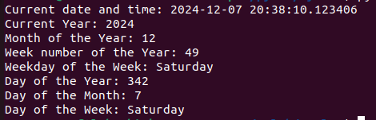

PROGRAM 3

AIM: Write a python program to print yesterday, today and tomorrow.

SOURCE CODE:
import datetime

today = datetime.date.today()

yesterday = today - datetime.timedelta(days=1)

tomorrow = today + datetime.timedelta(days=1)

print(f"Yesterday: {yesterday}")
print(f"Today: {today}")
print(f"Tomorrow: {tomorrow}")

OUTPUT:

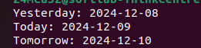

PROGRAM 4

AIM: Write a function in file palindrome.py to check whether a string is Palindrome or not. Import the module to find the longest palindromic substring in a given string by checking every possible substring and verifying if it is a palindrome

SOURCE CODE:

pg4.py

import palindrome

def longest_palindromic_substring(s: str) -> str:
longest = ""

for i in range(len(s)):
for j in range(i + 1, len(s) + 1):
substring = s[i:j]
if palindrome.is_palindrome(substring) and len(substring) > len(longest):
longest = substring

return longest

input_string = input("Enter a string: ")

result = longest_palindromic_substring(input_string)

print(f"The longest palindromic substring is: {result}")

palindrome.py

def is_palindrome(s: str) -> bool:
s = s.replace(" ", "").lower()
return s == s[::-1]

OUTPUT:

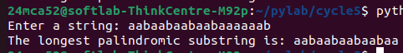

PROGRAM 5

AIM: Create a package graphics with modules rectangle, circle and sub-package 3D-graphics with modules cuboid and sphere. Include methods to find area and perimeter of respective figures in each module. Write programs that find the area and perimeter of figures by different importing statements. (Include selective import of modules and
import * statements)

SOURCE CODE:

graphics/circle.py
def area(radius):
from math import pi
return pi * radius * radius

def perimeter(radius):
from math import pi
return 2 * pi * radius

graphics/rectangle.py
def area(length, breadth):
return length * breadth

def perimeter(length, breadth):
return 2 * (length + breadth)

graphics/graphics3d/sphere.py
def area(radius):
from math import pi
return 4 * pi * radius * radius

def perimeter(radius):
from math import pi
return 2 * pi * radius

graphics/graphics3d/cuboid.py
def area(length, breadth, height):
return 2 * (length * breadth + breadth * height + height * length)

def perimeter(length, breadth, height):
return 4 * (length + breadth + height)

OUTPUT:

